BELMONT CITY COLLEGE

YEAR 11:(2AB) PHYSICS TEST – 2013

MOTION

Student Name: ______________________________

40

TIME: 1 Hour

* A data sheet is supplied for student use

NOTE:

1. Calculations must show clear working with answers written in scientific notation stated to three significant figures unless you are answering a question specifically asking you how many significant figures are technically required

2. Full Marks will be allocated for clear and logical setting out.

3. To help identify your answer, underline each answer.

4. State assumptions if working on open ended type questions.

5. Not all questions carry equal number of marks
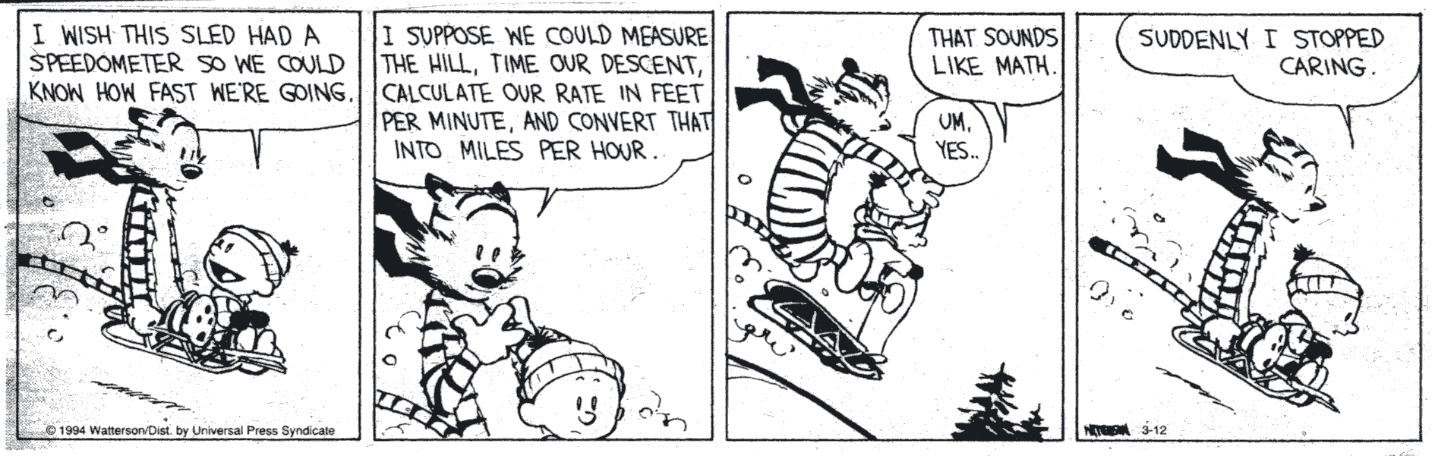
Q1. Listed below are physical quantities in scalar and vector columns. Circle the incorrect quantities from the two columns below
[3 marks]

Scalar | Vector
displacement | mass
speed | force
velocity | temperature
distance | acceleration
deceleration | energy

Convert the given numbers into scientific notation and express your answer correct to
3 significant figures.

  - 1 007 421 = __________________________

  - 0.0061856 = __________________________ [2 marks]

Q2. One of the most famous physics equations is E = m c² where m is the mass of the material in
kg, c is the speed of light which is 300 000 000.0 metres per second and E is the energy
produced in joules. If 0.00053 g of mass is theoretically converted into energy using the
above formula, convert the given numbers into scientific notation and calculate the
theoretical amount of energy in joules released. Round your answer to the technically correct
number of significant figures. [3 marks]

Q3. The velocity – time graph below shows the movement of a soccer (football) player moving in a straight line during part of a match. From the graph below:

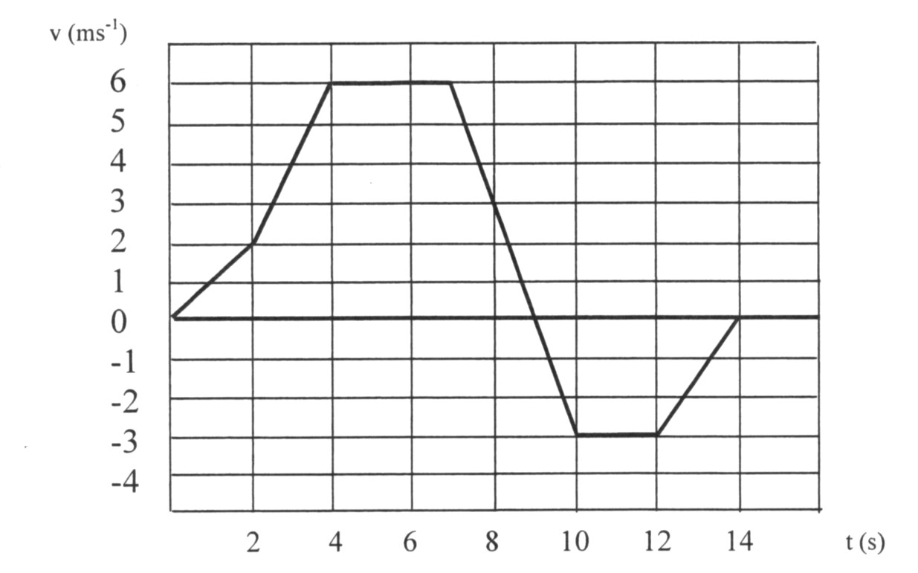

(a) Calculate the acceleration between t = 2.00 s and t = 3.00 s [1 mark]

(b) Calculate the acceleration between t = 7.00 s and t = 10.0 s. [1 mark]

(c) What distance does the soccer player cover in the first 6.00 seconds? [2 marks]

(d) What is the total displacement of the player between t = 0.00 s and t = 14.0 s? [2 marks]

Q4. The figure below shows a cricket ball as it comes into contact with a cricket bat.
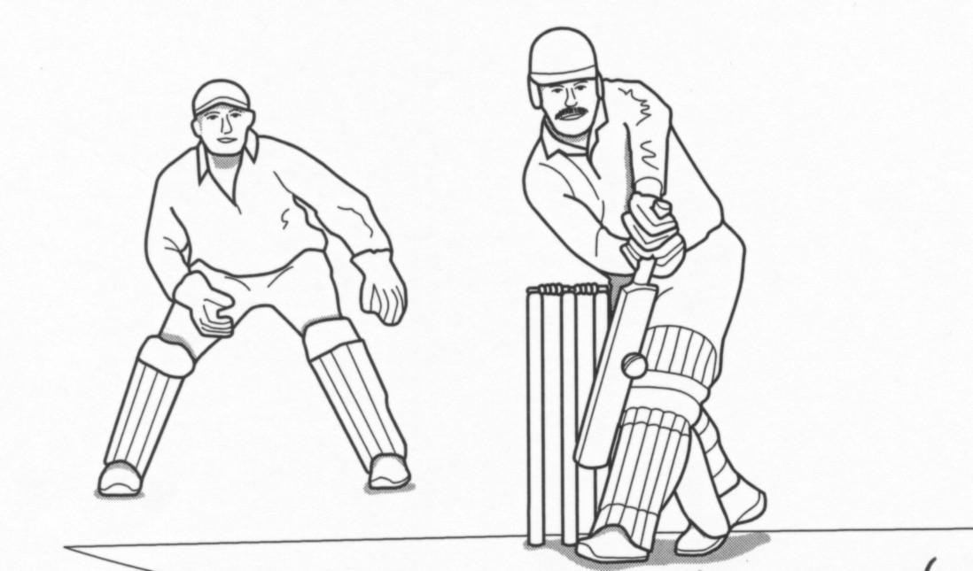

Ccc
cricket ball

The cricket ball has a mass of 0.16 kg and it hits the bat with a speed of 25.0 m s⁻¹. After being in contact with the bat for 3.32 milliseconds (ms) the ball rebounds with a speed of 22.0 m s⁻¹ in the direction exactly opposite to its original direction.

(a) State the difference between speed and velocity [1 mark]

…………………………………………………………………………………………………………

…………………………………………………………………………………………………………

(b) Calculate the change in velocity of the cricket ball. [2 mark]

(c) The average acceleration of the ball whilst it is in contact with the bat. [2 marks]

Q5. A motorcyclist visits his friend who lives 2.70 km East from his home. The motorcyclist
drops in at the shops after travelling in a straight line 1.30 km back to his home from his friends house.

- Draw a neat labelled vector diagram which is approximately to scale and identify the motorcyclist’s net or overall displacement. [1 mark]

- Calculate the motorcyclist’s overall displacement from his home to the shops. Include this
overall displacement value on your vector diagram above. [1 mark]

Q6. Mei Lin rowed out from the shore in her dinghy at a constant acceleration of 0.131 m s⁻². What
speed would she have reached travelling 45.1 m to her yacht anchored off shore? Neglect any friction. Show full working out. [3 marks]

Q7. A car travels due west for 17.5 km and it then travels 16.2 km due south. The total journey
takes 520 s.

(a) Complete a neatly labelled vector sketch of the car’s displacement below.

Vector diagram [2 marks]

(b) Calculate the car’s average speed for the journey. Show all working. [2 marks]

(c) Determine the car’s average velocity for the same journey. Show all working. [2 marks]

Q8. The table below shows the data from the department of transport on how the overall
stopping distance for a car varies with the speed of the car. The overall stopping
distance is the sum of the thinking distance and the braking distance.

Speed of car (m s⁻¹) | 10 | 15 | 20 | 25 | 30
Thinking distance (reaction distance) (m) | 6 | 9 |  | 15 | 18
Braking distance (m) | 8 | 18 |  | 50 | 72
Overall stopping distance (m) | 14 | 27 |  | 65 | 90

(a) Explain briefly what is meant by ‘thinking distance’? [1 mark]

…………………………………………………………………………………………………

…………………………………………………………………………………………………

- What is the relationship between the thinking distance and the speed of the car?
[2 marks]

………………………………………………………………………………………………

………………………………………………………………………………………………

……………………………………………………………………………………………….

………………………………………………………………………………………………..

(c) What is the thinking distance which corresponds to a speed of 20 m s⁻¹? [1 mark]

………………………………………………………………………………………………..

…………………………………………………………………………………………………

Q9. A jet aircraft, initially taxiing west on the runway at a constant speed of
3.40 metres per second, has its throttle fully opened so that it accelerates in a straight line along the runway with an average acceleration of 4.30 metres per second per second. Given that the aircraft is still on the ground accelerating, calculate the aircraft’s displacement over the period of time when the throttle is first fully opened till 13.7 seconds later. Neglect air and rolling resistance.
[3 marks]

Q10 For each of the v versus t graphs below describe the motion of the object in terms of change of velocity and acceleration. [1 mark /graph]

(a)

_______________________________

v _______________________________

_______________________________________________

t

(b) v ________________________________

_________________________________

_________________________________

t

_________________________________

(c) v __________________________________

__________________________________

t

__________________________________

__________________________________

+v ___________________________________

____________________________________
(d) t

- v

N.B. v = velocity in m s⁻¹ and t = time in s

END OF TEST – UNDERLINE AND CHECK YOUR ANSWERS!

